Lab 6: UML
Prepared by:
Youssuf Hatem Fathalla – 9575
Seif Karim Eldin Rashed – 9485
Omar Sharkawy – 9474
Hassan Soffar – 9554
Group 2 | Section 1

Use Case Diagram – SkillForge
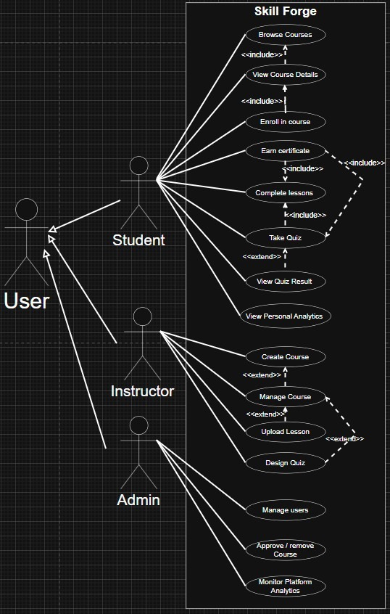
Use cases:
Browse Courses: The student views all available courses offered on the platform.
View Course Details: The student checks course information such as lessons and description.
Enroll in Course: The student registers for a selected course to begin learning.
Complete Lessons: The student studies and marks lessons as completed within a course.
Take Quiz: The student answers quiz questions related to the lessons they studied.
View Quiz Results: The student reviews their quiz scores and feedback.
Earn Certificate: The student receives a certificate after completing all course requirements.
View Personal Analytics: The student views statistics such as time spent, completed courses, and performance.
Create Course: The instructor designs a new course by adding its content and details.
Manage Course: The instructor edits, updates, or removes existing courses.
Upload Lesson: The instructor adds learning materials to specific courses.
Design Quiz: The instructor creates quizzes with questions and answers for their courses.
Manage Users: The admin adds, edits, or removes student and instructor accounts.
Approve / Remove Course: The admin reviews, approves, or deletes courses submitted by instructors.
Monitor Platform Analytics: The admin tracks system performance and usage statistics.
Actors:
User(generalization), Student, Instructor, Admin.
This diagram shows the main people who use the system: the Student, Instructor, and Admin and what each one can do inside SkillForge. It also shows which actions are always done together (include) and which are optional (extend). It’s important because it gives a simple overview of the system before coding, so we can easily understand what every user does and his roles and how the system’s features should work.

Class Diagram – SkillForge
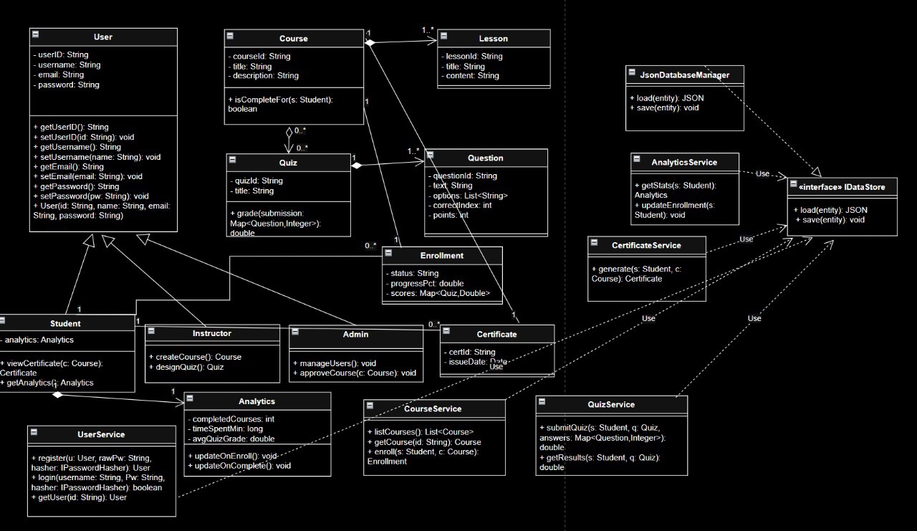
This class diagram shows the system structure including classes, their attributes, and relationships such as inheritance, association, aggregation, and composition. It is important because it visualizes how objects relate and ensures the correct application of OOP concepts before implementation.

Sequence Diagram – Enroll in Course
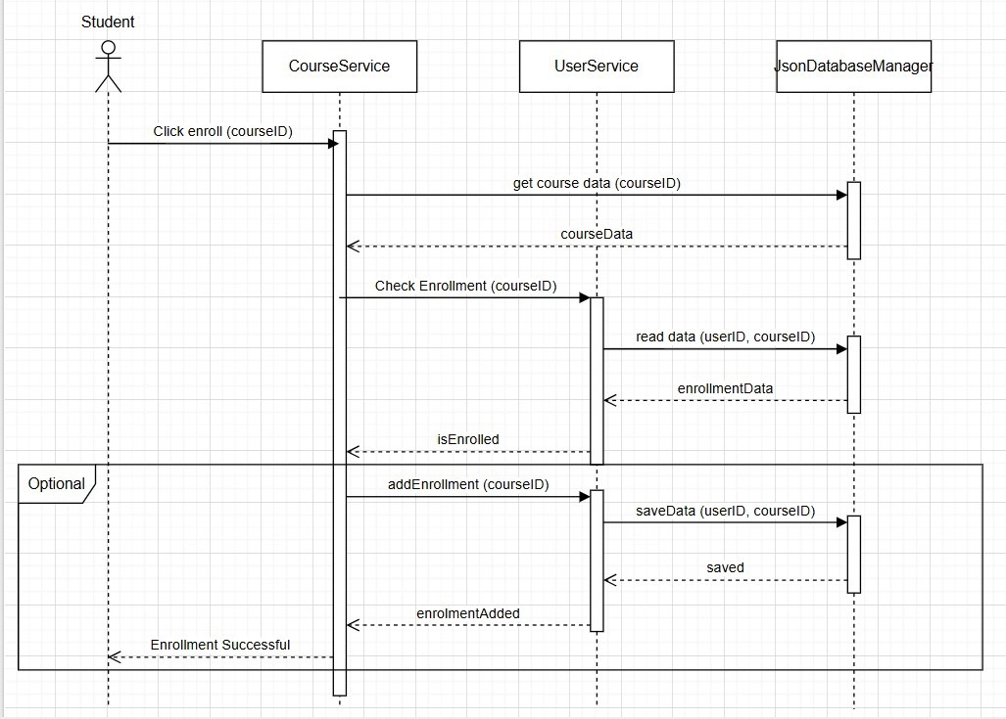
This sequence diagram shows how a student enrolls in a course by interacting with CourseService, UserService, and JsonDatabaseManager to check and save enrollment data. It is important because it clarifies the order of interactions and verifies the logic of the enrollment process.

Activity Diagram – Enrollment Process
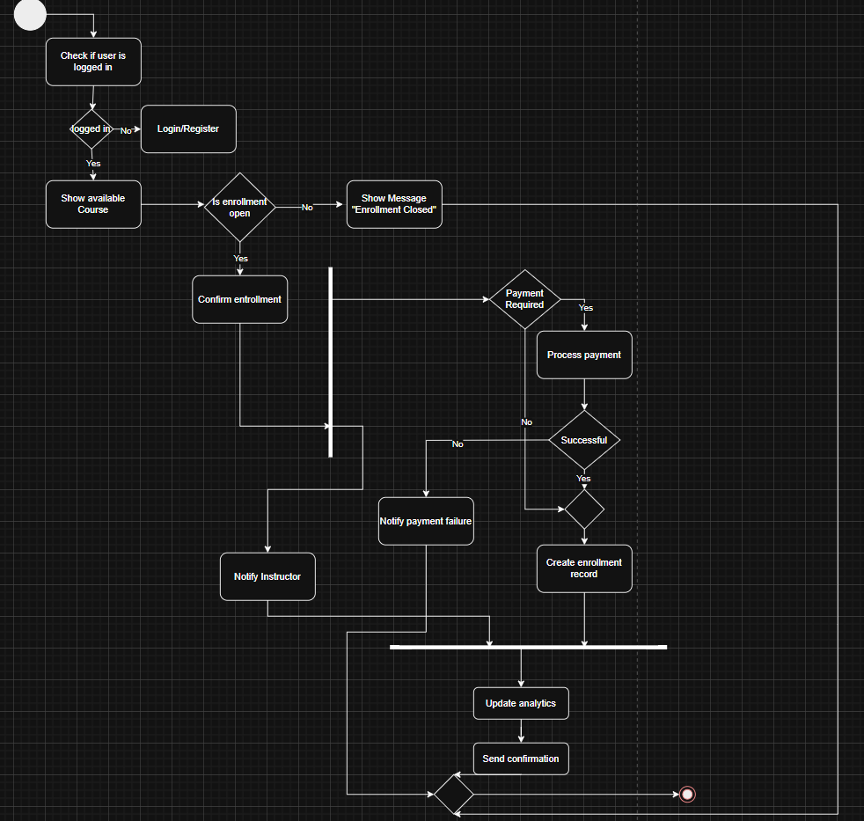
This activity diagram illustrates the workflow of the student enrollment process from login and course availability through payment (if required) to confirmation. It highlights key decision points such as payment verification and enrollment status, and shows the actions taken when the payment succeeds or fails. It is important because it clearly represents the logical flow of the enrollment process and helps visualize system behavior.

